Vocabulary
n.) Frankenstein | v.) stitch  v.(p.p.)) stitched (together) | n., adj.) Hebrew
adj., n.) hit-and-run | v., n.) siphon | v.) post n.) bail

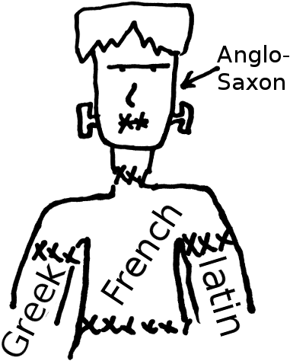
Reading
English is a Frankenstein monster language; it’s stitched together from the body parts of many languages; some of them long dead!
 Chutzpah 
“That quality in a man who, having killed his mother and father, throws himself on the mercy of the court because he is
an orphan."
Source: The Joy of Yiddish (Rosten)
English has ancient roots—Frisian, Anglo-Saxon, Viking—and has adopted (and adapted) words from many other languages—French, Greek, Latin, Spanish, and even Chinese and Yiddish.
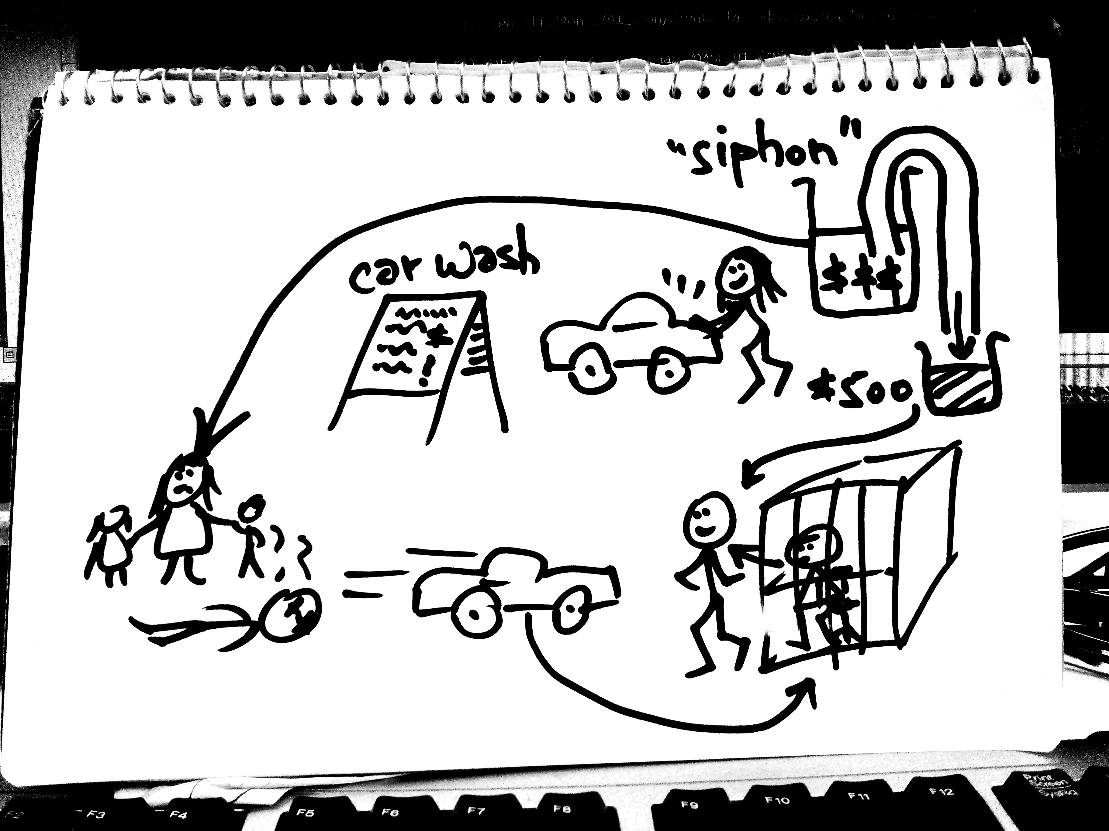
Yiddish is from central Europe, a mix of Hebrew and German. It has lots of colorful words, many of which are still in common use. One such word is “chutzpah”:
1
2
3
4
5
Chutzpah! Mallory Ewart, 18, organized a charity car wash¹ for the family of a man killed in a hit-and-run collision² in Washington State. She raised hundreds of dollars. She presented some of it to the family³. According to police, she siphoned off $500⁴ to post bail for her boyfriend⁵—who is the driver accused of the hit-and-run².
—Chuck Shepherd’s News of the Weird
The meaning of the word “chutzpah” has changed over the years. In the original Yiddish, it describes a bad person who feels no shame for the bad things they do. In modern America, it has taken on an alternate, positive meaning; someone who “has guts” (emotional strength), and commands respect. This is very different from the original meaning.

Questions:
- Do you know a “chutzpah story”? This is a story about someone who exhibited chutzpah. This could be from your own personal experience, or perhaps you know a story from Chinese legend or history, or saw a story on the TV news.
GLOSSARY of common Yiddish Words
Word | Definition | Example
bupkis | Nothing. Something totally worthless | “He got everything. I got bupkis!”
chutzpah | Brazenness, gall, shamelessness | “You got a lot of chutzpah saying that, seeing how you screwed over your own son!”
drek | - Human excrement; inferior merchandise or work.  - insincere talk; bullshit | “No, I don’t want to go shopping there. I checked it out last month: Nothing but drek!”  “Don’t give me that drek.” (Don’t bullshit me)
klutz | An awkward, clumsy person. | “Geez, I’m such a klutz! Sorry!”
kosher | - Food which subscribes to Jewish dietary laws.  - Referring to the propriety of a course of action. | “Are you sure inviting your ex-wife to your office promotion party would be kosher?”
kvetch | v.) Whine, complain.  n.) A whiner, a complainer | “Oh, stop kvetching! You have it so easy!”
meshugeh | Crazy | “My brother, God bless him. He means well, but he’s a little meshugeh!”
nosh | v., n.) Snack | “I won’t be long at the party. I’ll schmooze a little, nosh a little, and then I’ll be right back.”
schlep | v.) Drag, carry or haul, particularly large, heavy things.  n.) A person who does this kind of work. | “Hey, Rick. Could you help me schlep these boxes up to the 5th floor?”  “Hey! Don’t ask me: I’m just a schlep!”
n.) schmaltz, adj.) schmaltzy | - Literally, “chicken fat”  - Flattery; sweet talk.  - Overly theatrical, melodramatic, corny. | “Sorry, but I just don’t fall for that schmaltz. I like my movies to have solid stories.”  “God, this soap opera is so schmaltzy! Change the channel before I barf!”
schmooze | Chat, talk, hobnob, socially network, “work the room” | “It’s a good idea to go to the bar with your coworkers. We all need to schmooze a little from time to time.”


