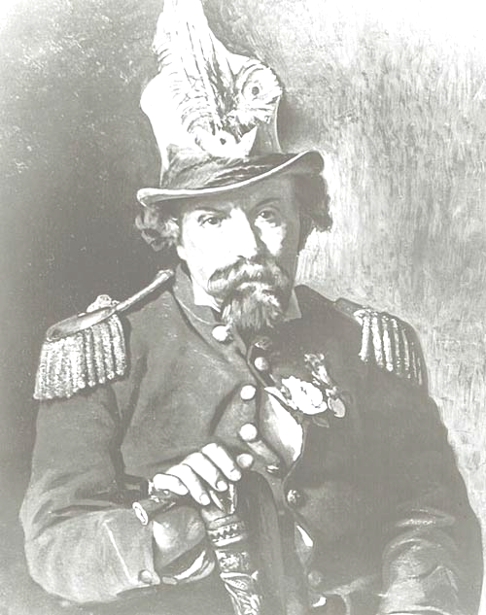
The year was 1880, in San Francisco, California, the United States.
Joshua Abraham Norton, Emperor of the United States and Protector of Mexico

On January 8th, a late-middle-aged man was walking to a lecture at the State Academy of Sciences when he collapsed and fell to the sidewalk. He died before a carriage could arrive to take him to a hospital.
The city reeled at the news. Two days later, on the 10th, a funeral procession was arranged. Thirty thousand San Franciscans—at the time, about one tenth of the population of the city—showed up to walk behind Joshua A. Norton’s body as it made its way to the cemetery.
Indeed, the death of your Emperor is an earth-shattering event.
In modern parlance, Joshua Norton was a “street crazy”; an apparently delusional fellow who, rather than being placed into a psychiatric ward, lived among the citizens and roamed the streets.
He had been a high-roller businessman who sadly lost all his money, and even his properties, due to the unexpected failure of a major investment. After this catastrophe, he disappeared for a while. When he returned, friends noted that he had “changed”. He started informing people that he was the Emperor of the United States,  and  Protector of Mexico.
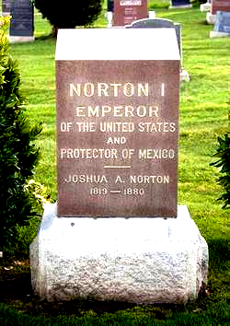
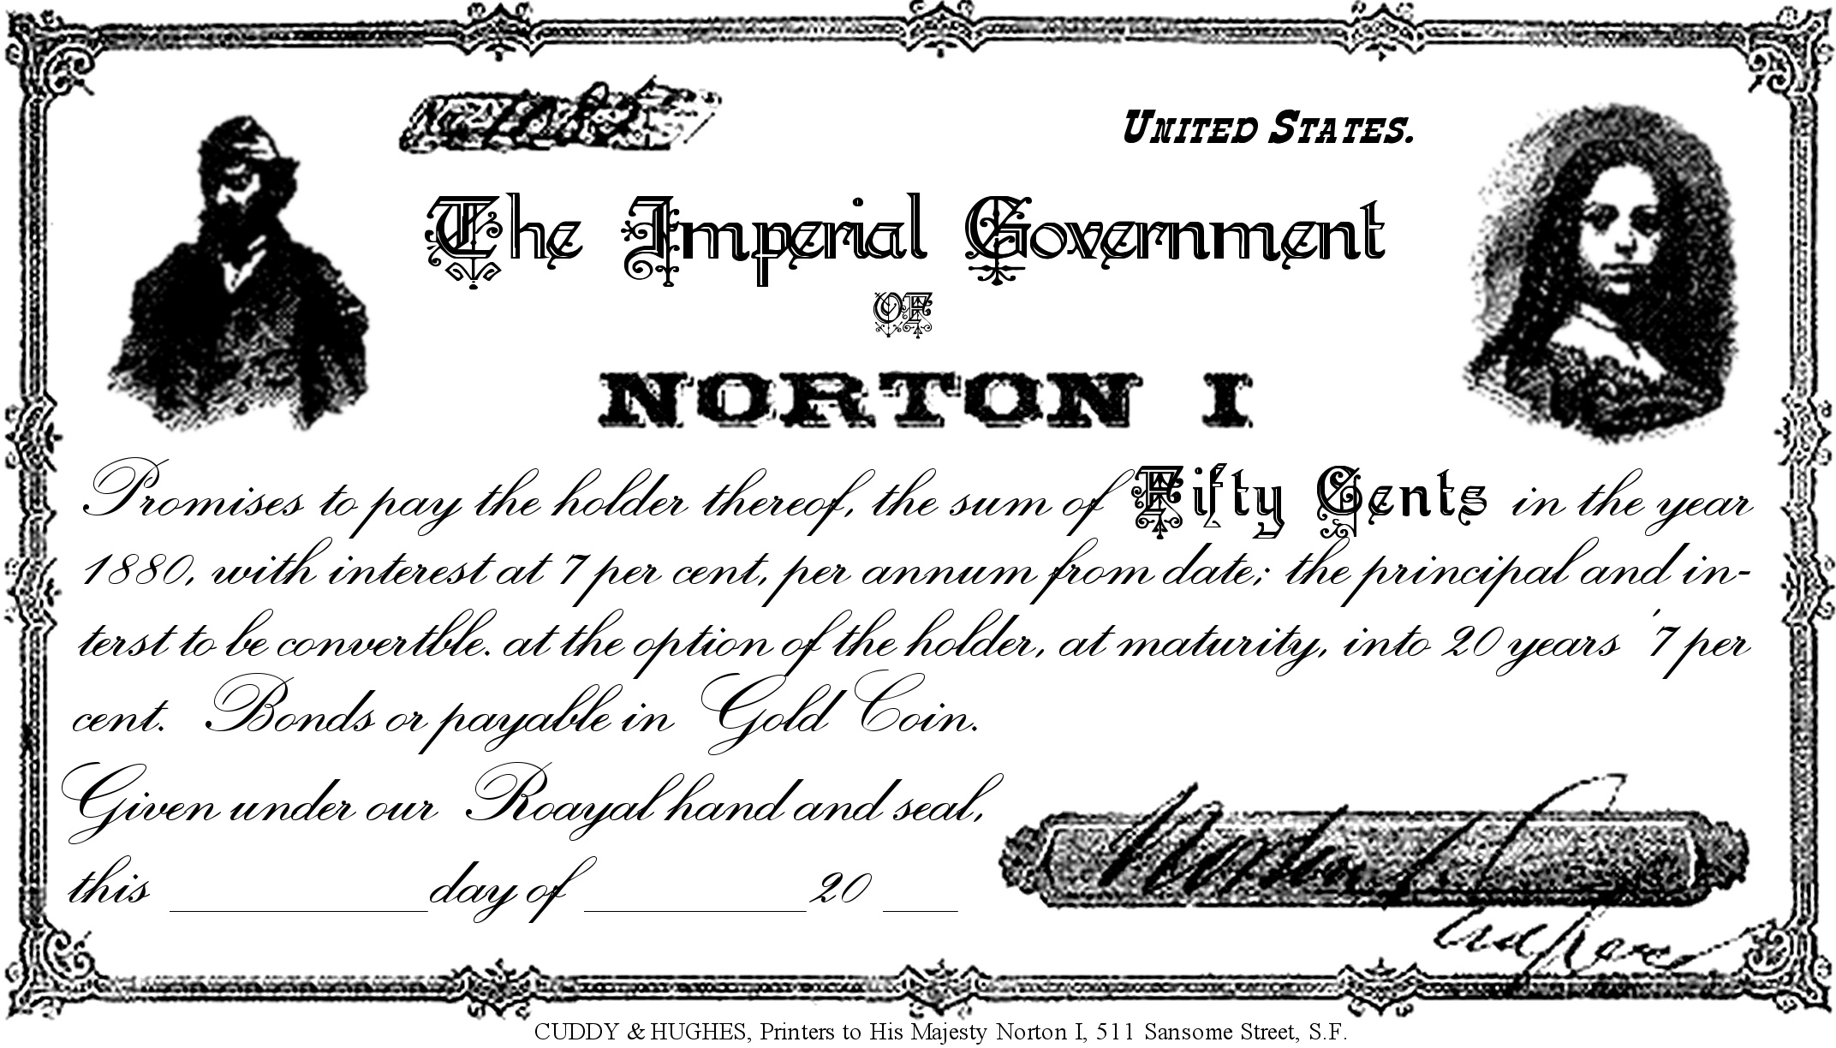
Strangely, many San Franciscans took to their new Emperor. People cheerily addressed him, “Hello, Emperor Norton!”—and he responded with noblesse oblige. A local tailor made him a nice, sharp-looking Emperor suit, and would make him new ones whenever he started looking a little frayed around the edges. A number of restaurants allowed him and his dogs to eat for free. Newspapers competed for the privilege of publishing his “royal proclamations”. A local printer drew up and printed promissory notes (pictured), which many local businesses accepted as money.
Everybody understands Mickey Mouse.
Few understand Herman Hesse.
Only a handfull understood Albert Einstein.
And nobody understood Emperor Norton.
- Slogan of NORTON CABAL- S.F., POEE
Emperor Norton I remains an enigma. Was he just a loon? Or did he have that extra “something special”?

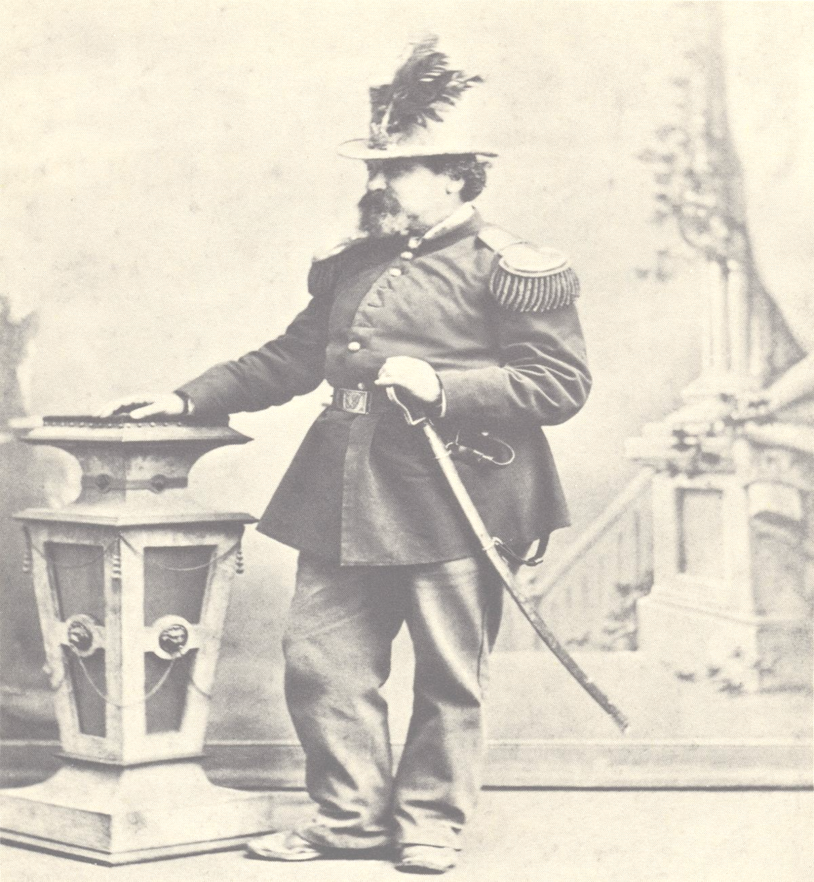 |  |  |  |  |  |  | 1 |  |  |  |  | 2 |  |  |  |  |  |  |  |  | 3
 | 4 |  |  |  |  | 5 |  |  |  |  |  |  |  |  |  | 6
 |  |  |  |  |  |  |  |  |  |  | 7
 |  |  |  | 8 |  | 9
 |  |  |  |  |  |  |  |  |  |  |  |  |  |  | 10 |  | 11
12 |  |  |  |  |  |  |  |  |  |  |  |  |  |  |  |  |  |  | 13
 |  |  |  |  |  |  |  |  |  |  |  |  |  | 14
 |  |  | 15 |  |  | 16
17 |  |  |  |  |  |  |  |  |  |  |  |  |  | 18
 |  |  |  |  |  |  |  |  |  |  | 19
20 |  |  |  |  |  |  |  | 21 |  |  |  | 22 |  |  | 23
24

 |  |  |  |  |  |  | 25

ACROSS  Sincere belief in an untrue thing  A problem that can't be solved using logic  Everything suddenly falls apart  Public meeting to remember the dead  The obligation of the high-born to be nice to ordinary people (two words  Old word for a horse-drawn cart  Somber parade  Bold statement  Spending money to make money  Offering mental/emotional care  Lose integrity and fall to the ground  School  Leader of an empire | DOWN  Public talk; by a professor, for example  Noble-born  Develop an enjoyment for (two words)  A successful person, in business (slang; two words)  U.S. State where one finds San Francisco  Happily  Become ragged at the edges  Section of a hospital  Lingo; common language, for a time and place  Place where the remains of the dead are kept  To be shocked  Wander about  A large, northern water bird; also slang for a crazy person

