Vocabulary
adj.) residential  v.) reside / n.) residence | adj.) garage n.) sale | adj.) paperback n.) edition
n.) occurrence  v.) occur | adj.) keen | n.) appreciation  v.) appreciate


Reading
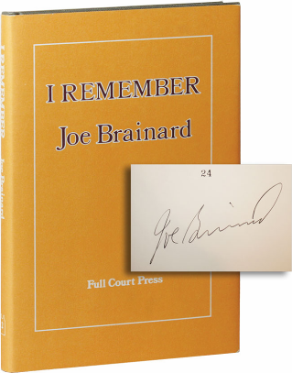
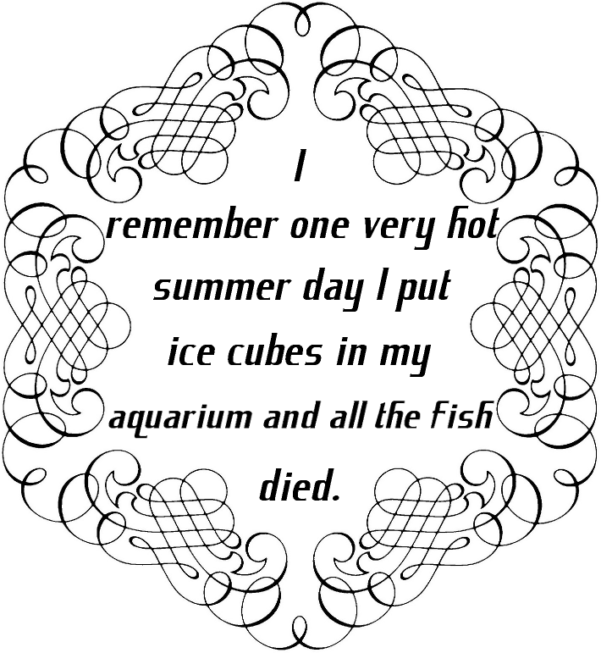
I remember walking down a residential street in Lansing, Michigan (U.S.A.) around 1980 or so. I saw a garage sale and walked over to see if there was anything interesting.
I came across an old paperback edition of
← Joe Brainard’s I Remember.
I opened it up and started reading. It took me a few minutes to figure out what Mr. Brainard was doing. The book was about 100 pages long, and each page had 8 to 15 little memories of things or thoughts or occurrences from his life.
Joe had a good memory for details, and a keen appreciation of his own past.
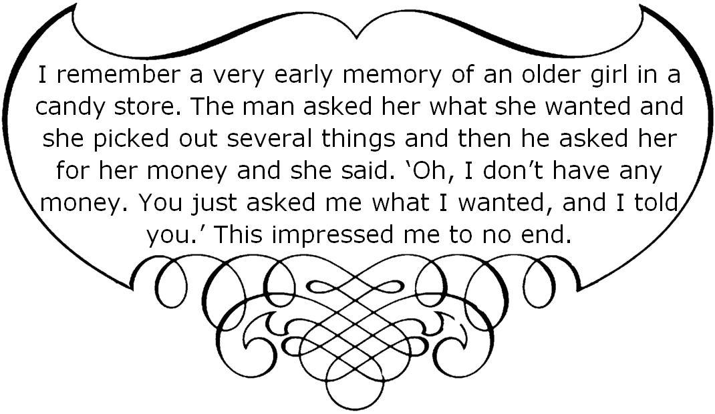
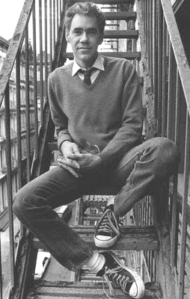
Well, maybe this talent isn’t really that special. Perhaps we should all occasionally take time out to remember details from our own lives.
Joe Brainard
(1941–1994)

Activity
- It’s simple, really: We’re going to go around the room, and I want each of you to remember things from your life.
What should you look for?:

  - Try to remember very early things.
  - Try to remember unusual or special things.
  - Try to remember emotional things.
  - Try to remember things you thought you’d forgotten, but haven’t.

[ ]
remember
I
Noun Phrase:
[Gerund]
“…going to the park with my dog, one day.”
b
[Simple Noun Phrase]
“…one time when I was a kid.”
“…a dog in our neighborhood.”
a
Relative
Clause:
that
[Sentence]
<Subject> <Verb> [<Object Direct>]… .
1
2
3
, , , …
4
5

